PAC-POLY-New Hebrides-Erromanga-Cook-1784

## The Landing of Captain Cook &c at Erramanga, one of the New Hebrides

33 cm x 20.5 cm copperplate engraving, 36.5 cm x 23.5 cm sheet size, Alexander Hogg, London, 1785

We are pleased to offer this scarce and historically important image of the violent encounter with Melanesian natives on the island of [Erromango](http://www.britannica.com/EBchecked/topic/191906/Erromango) in the New Hebrides (now Vanuatu) by Captain James Cook on his second voyage of discovery and engraved for the *New, Authentic, Entertaining, Instructive, Full and Complete Historical Account of Captain Cook's First, Second, Third and Last Voyages*[1](http://vi.vipr.ebaydesc.com/ws/eBayISAPI.dll?ViewItemDescV4&item=251700923029&t=1414385602000&tid=10&category=360&seller=regiomontanus&excSoj=1&excTrk=1&lsite=0&ittenable=false&domain=ebay.com&descgauge=1" \l "1) published serially between 1784 and 1786.  On 4 August 1774 Cook left the *Resolution* with a small party of marines to visit the island where he was invited ashore in what appeared to be peacful entreaties from the inhabitants.  Upon reaching the beach the chieftain then ordered an attack with stones, darts and arrows forcing Cook to fire in self defence.   The plate was engraved after an original drawing of the scene made by the expedition's artist [William Hodges](http://en.wikipedia.org/wiki/William_Hodges) (1744-1797) most likely based on Cook's account of the incident and not as an eyewitness - Hodges later made an oil painting of the scene as well.  Trained as a landscape artist, Hodges's orders from the Admiralty as conveyed to Cook were to "diligently employ himself in making Drawings or Paintings of such Places as you may touch that may be worthy of notice in the course of your Voyage as also of other Objects and things as may fall within the Compass of his Abilities", orders that Hodges certainly met and exceeded as this dramatic scene demonstrates.  Cook records the violent encounter in his journals that left at least four natives seemingly dead:

"...our own safety became now the only consideration and yet I was very loath to fire upon such a Multitude and resolved to make the chief alone fall a Victim to his own treachery, but my Musquet at this critical Moment refused to perform its part and made it absolutely necessary for me to give orders to fire’; the people thus thrown into confusion, a second discharge drove them off the beach, though they continued to throw stones and darts from the shelter of the bushes... Happy for many of these poor people not half our Musquets would go off or otherwise many more must have fallen."2

Beautifully engraved with excellent fidelity to Hodges's original drawing, this example of the print presents an exceptionally strong and dark impression and will make a elegant presentation if matted and framed as well as an important addition to any collection related to the explorations of James Cook.

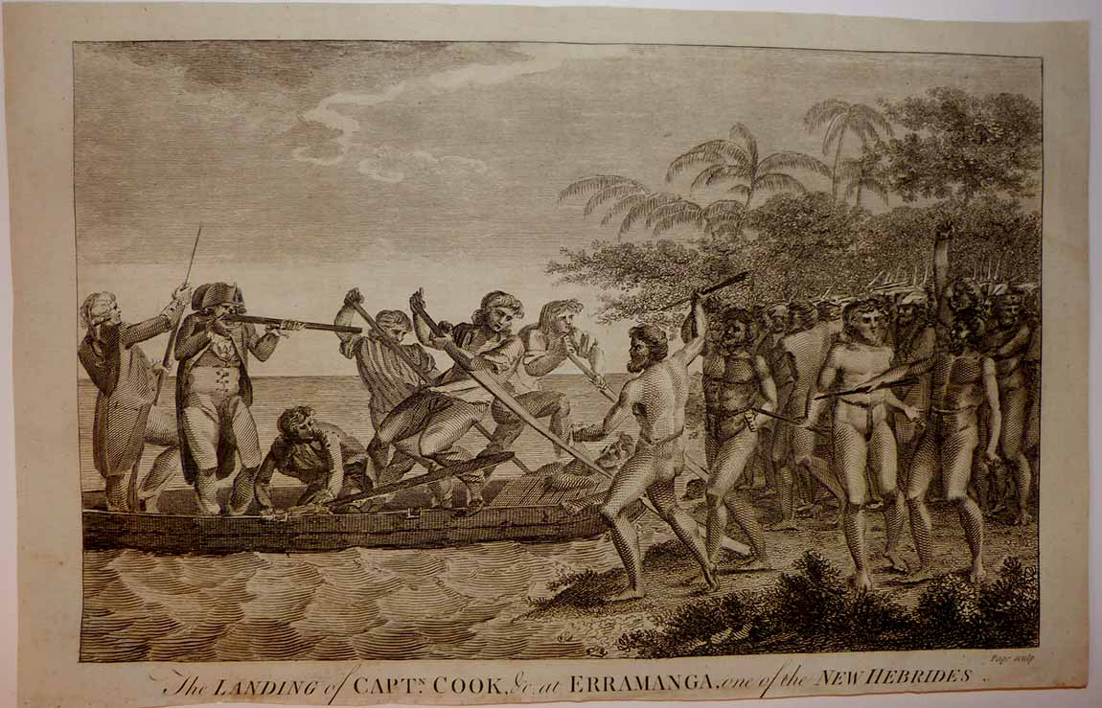

Some historians have claimed that the encounter actually transpired on the tiny "Goat Island" that lies just outside Polonia Bay on Erromango Island where Cook's ships were anchored, but this seems unlikely as his principal reason for going ashore was a quest for wood and fresh water which would of course be more abundant on the larger Erromango.  To get a sense of print detail consider that Cook's "Musquet" as seen below measures just 5 cm long actual size:

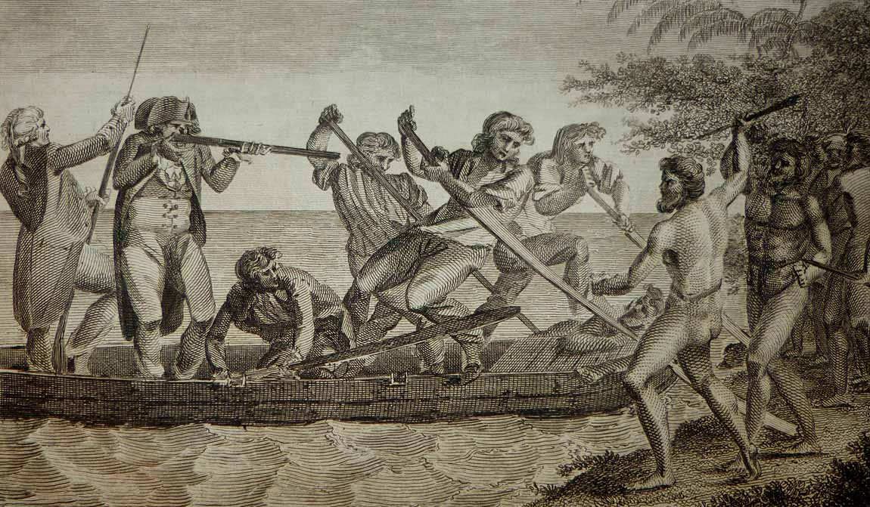

Condition - Please note carefully:  The print is in overall very good condition as can be ascertained from photos, strong impresssion on fine quality laid paper, image area essentially pristine, no text on verso, no folds.  Close and slightly uneven trim to all margins, two small chips to lower margin reinforced on verso with acid-free tape, trivial scattered soiling to margin extremities.  [Inquiries](mailto:jfazli@ix.netcom.com) welcome and we encourage you to visit our other [listings](http://cgi6.ebay.com/aw-cgi/eBayISAPI.dll?ViewListedItems&userid=regiomontanus&sort=3&since=-1) on eBay.  
  
NOTES:  
  
1. The editor of the *New, Authentic, Entertaining, Instructive, Full and Complete Historical Account of Captain Cook's First, Second, Third and Last Voyages* was named as one "George William Anderson",  almost certainly a pseudonym for the publisher Alexander Hogg.  In a recent exhibition of these historically important engravings made for this publication the Lowe Art Museum in Miami noted that the pseudonym was "a device Hogg employed in a number of his publications" intended to convey an "aura of authoritative knowledge" regarding his editing of the official publications of the voyages.  Hogg shrewdly elected to publish the work (which eventually included accounts of other circumnavigations) in a relatively affordable serial format from 1784-1786 to reach a broad audience, noting in his marketing copy that this was "due to the many thousands of Persons who would wish to peruse the Discoveries... and view the astonishing fine Copper-Plates, who have hitherto been excluded from gratifying their eager curiosity.  These installments would allow every Person, whatever may be his Circumstances, to read about the voyages of which such vast Sums of the Public Money have been expended."  Note that we are offering this "astonishing fine Copper-Plate" as published and without hand colour - while some of the engravings after Hodges's drawings lend themselves quite nicely to modern hand colour, this print is not in that category as the result would inevitably obscure the engraved line of such a strong impression.   
  
2. Cook, James. *A Voyage Towards the South Pole and Round the World: Performed in His Majesty’s Ships the Resolution and Adventure, in the Years 1772, 1773, 1774 and 1775*. 1st ed. 2 vols. London, 1777